# VISVESVARAYA TECHNOLOGICAL UNIVERSITY

# BELAGAVI, KARNATAKA - 590018

DBMS MINI PROJECT REPORT ON

# “CAR RENTAL MANAGEMENT SYSTEM”

# Submitted by

|  |  |
| --- | --- |
|  |  |
| **PRANEETH**  **THOUFEEQ M I** | **4DM20IS034**  **4DM20IS054** |
|  |  |
|  |  |

UNDER THE GUIDANCE OF

**Mrs.Pranitha**

**Assistant Professor, Dept. Of ISE**

***In the partial fulfilment for the award of the degree of***

BACHELOR OF ENGINEERING

IN

INFORMATION SCIENCE AND ENGINEERING

|  |
| --- |
|  |



**YENEPOYA INSTITUTE OF TECHNOLOGY**

N.H. 13, Thodar, Vidyanagar, Moodbidri, Mangalore,

Karnataka - 574225

**2022-2023**

### **YENEPOYA INSTITUTE OF TECHNOLOGY**

N.H.13, Thodar, Vidyanagar, Moodbidri, Mangalore, Karnataka 574225

(Affiliated of Visvesvaraya Technological University)

**DEPARTMENT OF INFORMATION SCIENCE & ENGINEERING**



**CERTIFICATE**

Certified that the DBMS Mini Project Workmentitled **“CAR RENTAL MANAGEMENT SYSTEM**” carried out by **Mr. Praneeth(USN 4DM20IS034), Mr. Thoufeeq M I(USN 4DM20IS054),**bonafide student of **Yenepoya Institute Of Technology** in partial fulfillment for the award of **Bachelor of Engineering in Information Science & Engineering** of the **Visvesvaraya Technological University**, Belagavi during the year **2022-23**. It is certified that all corrections/suggestions indicated for Internal Assessment have been incorporated in the report deposited in the departmental library. The project report has been approved as it satisfies the academic requirements in respect of project work prescribed for the said degree.

**………………………. ….…………………**

***Prof. Pranitha Dr. Manjula V***

***(Internal guide) (HOD)***

**External Viva**

**Name of the examiners Signature with date**

**1.**

**2.**

**TABLES OF CONTENTS**

**CHAPTER NO TITLE PAGENO**

1. **ACKNOWLEDGMENT** 5
2. **ABSTRACT** 6
3. **LIST OF FIGURE**  7

1. **Introduction**
   1. What is Database? 09
   2. Types of Database 11

1.2.1 Centralized Database 11

1.2.2 Operational Database 12

1.2.3 End User Database 12

1.2.4 Commercial Database 12

1.2.5 Personal Database 13

1.2.6 Distributed Database 13

1.3 Objectives 14

1.3.1 Existing System 14

1.3.2 Proposed System 15

1. **System requirements and specification**

2.1 Hardware Requirements 16

2.2 Software Requirements 16

1. **Front End**

3.1 HTML,CSS and JavaScript 17

3.2 Pseudo Code 24

1. **Back End**

4.1 My SQL and PHP 27

4.2 Database Tables 31

4.5 Triggers 38

4.6 Stored Procedure 39

1. **Snapshot and Results** 40
2. **Conclusion**  48
3. **References**  49

**I**

**ACKNOWLEDGEMENT**

The successful completion of any work would be incomplete without a mention of the people who made it possible, whose constant guidance and encouragement served as a beacon light and crowned our efforts with success. We owe our gratitude to many people who helped and supported us during my DBMS Mini Project “CAR RENTAL MANAGEMENT SYSTEM”.

My deepest thanks to my guide Mrs.Pranitha, Assistant Professor, Dept. of ISE, Yenepoya Institute of Technology for constant support and encouragement and providing with the necessary advice and help. We are highly indebted to her for talking keen interest in my work, monitoring and providing guidance throughout the course.

I sincerely express our gratitude to Dr. Manjula V, H.O.D, Dept. of ISE for his constant support and guidance for the successful completion of this DBMS Mini Project.

I take immense pleasure in thanking my beloved Principal Dr. R. G D’Souza for his constant support.

I also thank my lectures who were ready with a positive comment to help me all time, whether it was an off-hand comment to encourage me or a constructive piece of criticism.

I also thank all laboratory administrates and assistants who have helped us in making this project a successful one.

At last but not the least I want to thank our classmates and friends who appreciated our work and motivated us.

PRANEETH 4DM20IS034

THOUFEEQ M I 4DM20IS054

**II**

**ABSTRACT**

The Car Rental System is being developed for customers so that they can book their vehicles from any part of the world. This application takes information from the customers through filling their details.A customer being registered in the website has the facility to book a vehicle which he requires. It is an online system through which customers can view available cars, register and book car.We developed this project to book a car on rent at the fare charges. In present system all booking work done manually and it takes very hard work to maintain the information of booking and cars.If you want to find which vehicle is available for booking then it takes a lot of time. It only makes the process more difficult and hard.This aim of the project is to automate the work performed in the car rental management system like records of cab, cabs available for booking, rental charges for cars, store records of the customer.PRENDER is a car booking software that provides a complete solution to all your day-to-day car booking office running needs. This system helps you to keep the information of customer online. You can check your customer information any time by using this system.Online car rental management system is a unique and innovative product. Based on this information you can take decision regarding your business development.

**III**

**LIST OF FIGURES**

Figure 4.3: Schema Diagram ....…..............................................................35

Figure 4.4:E-R Diagram…………………………………………………..36

Figure 5.1: Home Page ...............................................................................40

Figure 5.1.1: Admin Login Page.................................................................41

Figure 5.1.1.1:Available Cars......................................................................41

Figure 5.1.1.1.1: Add Car Details..................…..........................................42

Figure 5.1.1.2: User Details ........................................................................42

Figure 5.1.1.3: Feedback Dashboard ..........................................................43

Figure 5.1.1.4: Booking Dashboard.............................................................43

Figure 5.1.2: User Sign-up Page..................................................................44

Figure 5.1.3:User Dashboard.......................................................................44

Figure 5.1.3.1: Booking Of Cars…..............................................................45

Figure 5.1.3.2: Feedback Of User.........………...........................................45

Figure 5.1.3.3:Booking Status.....................................................................46

Figure 5.1.4:About Us……………………….............................................46

Figure 5.1.5:Contact Us…………………………. ....................................47

**Chapter 1**

**INTRODUCTION**

This document aims at defining overall software requirement for CAR RENTAL MANAGEMENT SYSTEM.Efforts have been made to define the requirements exhaustively and accurately. The final product will be having only features/functionalities mentioned in this document and assumptions for any additional functionality/feature should not be made by any of the parties involved in developing/testing/implementing /using this product.

**Car Rental Management System divided in two modules–**

* User
* Admin

**Users Features**

* User having sign-up and login option.
* User can choose his favourite car and he/she can book the car.
* User can make payment and he/she can see their booking status.

**Admin Features**

* Admin Dashboard.
* Admin can add/delete the cars.
* Admin can view/delete the user.
* Admin can see the users feedback.
* Admin can approve the cars.
* Admin can add the updation statement of cars

**1.1** **What is Database?**

A database, management system (DBMS) is system software for creating and managing database. The DBMS provides users and programmers with a systematic way to create, retrieve, update and manage data.

A DBMS makes it possible for end users to create, read, update and delete data in a database. The DBMS essentially serves as an interface between the database and end users or application programs, ensuring that data is consistently organized and remains easily accessible.

The DBMS manages three important things, the data, the database engine that allows data to be accessed, locked and modified and the database schema, which defines the database’s logical structure. These three foundational elements help provide concurrency, security, data integrity and uniform administration procedures. Typical database administration tasks supported by the DBMS include change management, performance monitoring, tuning and backup and recovery. Many database management systems are also responsible for automated rollbacks, restarts and recovery as well as the logging and auditing of activity.

The DBMS is perhaps most useful for providing a centralized view of data that can be accessed by multiple users, from multiple locations, in a controlled manner. A DBMS can limit what data the end users sees, as well as how that end user can view the data, providing many views of a single database schema. End users and software programs are free from having to understand where the data is physically located or on what type of storage media it resides because the DBMS handles all requests.

The DBMS can offer both logical and physical data independence. That means it can protect users and applications from needing to know where data is stored or having to be concerned about changes to the physical structures of data (storage and hardware). As long as programs use the applications programming interface (API) for the database that it provided by the DBMS, developers wont’s have to modify programs just because changes have been made to the database.

Databases and database technology have a major impact on the growing use of computers. It is fair to say that databases play a critical role in almost all areas where computers are use, including business, electronic commerce, engineering, medicine, genetics, law, education, and library science. The word database is so commonly used that we must begin by defining what a database is. Our initial definition is quite general.

A database is a collection of related data. By data, we mean known facts that can be recorded and that have implicit meaning [1]. For example, consider the names, telephone numbers, and addresses of the people you know. You may have recorded this data in an indexed address book or you may have stored it on hard drive, using a personal computer and software such as Microsoft Access or Excel. This collection of related data with an implicit meaning is a database.

A database management system (DBMS) is a collection of programs that enables users to create and maintain a database. The DBMS is a general-purpose software system that facilitates the processes of defining, constructing, manipulating, and sharing database among various users and applications. Defining a database involves specifying the data types, structure, and constrains of the data to be stored in the database. The database defining or descriptive information is also stored by the DBMS in the form of a database catalog or dictionary; it is called meta-data. Constructing the database is the process of storing the data on some storage medium that is controlled by the DBMS. Manipulating a database includes functions such as querying the database to retrieve specific data, updating the database to reflect changes in the mini world, and generating reports from the data. Sharing a database allows multiple users and programs to access the database simultaneously. An application program accesses the database by sending queries or requests for data to the DBMS. A query2 typically causes some data to be retrieved.

**1.2 Types of Database**

The different database types are:

* Centralized database
* Operational database
* End-user database
* Commercial database
* Personal database
* Distributed database

**1.2.1 Centralized database**

Users from different locations can access this database from a remote location at the central database, that store entire information and application program at a central computing facility for processing. The application programs pick up the appropriate data from the database based on the transactions sent by the communications controller for processing the transaction.

Data validation and verification is carried out by the application program at the central computer center, and a registration number is allotted by the application programs located at the central facility.

The local area office keeps on recording it and hardly does any processing.

**1.2.2 Operational database**

This is more of a basic form of data that contain information relating to the operations of an enterprise. Generally, such databases are organized on functional lines such as marketing, production, employees, etc.

**1.2.3 End user database**

End user is the user of software, application or a product. This is a shared database which is shared by users and is meant for use by the end users, just like managers at different levels. They may not be concerned about the individual transactions as found in operational database. This database is more about the summary of the information.

**1.2.4 Commercial database**

This is a database that contain information which external users may require. However, they will not be able to afford maintaining such huge database by them. It’s a paid service to the user as the databases are subjected specific. The access to commercial database can be given through commercial links.

Some of the database service providers also offer databases on CD-ROMs and the updated versions of the databases are made available periodically. The databases on CD-ROMs have advantages of reduced cost of communication.

**1.2.5 Personal database**

The personal databases are maintained, generally, on personal computers. They contain information that is meant for use only among a limited number of users, generally working in the same department.

**1.2.6 Distributed database**

These databases have contributions from the common databases as well as the data captured from the local operations. The data remains distributed at various sites in the organization. As the sites are linked to each other with the help of communication links, the entire collection of data at all sites constitutes the logical database of the organization.

It includes definition of various levels of hierarchy in an organization, the salary structure pertaining to every element in this hierarchy, the description of every department functioning in the organization and the overall employ database which integrates elements in all the aforementioned.

It has a database administration that has access to the entire database, in regards with viewing and update of information. The exclusive right is implemented using authorized access. Also viewing all data and editing of personal data can be done by any employee, this also using Authorized access. Communication between personnel and administrator has also been provided for.

The data can be accessed, manipulated and retrieved very easily. The interface has been made very user friendly. The data is well protected for use and the data processing i.e., results of query functions has been made very quick and efficient.

**1.3 Objectives**

The proposed system is set for the following objectives.

* To produce a web-based system that allow customer to register and reserve car online and for the company to effectively manage their car rental business.
* To ease customer’s task whenever they need to rent a car.
* As all the system is computerized, there is no need to fill any application form for renting purpose. So, the paperwork will be very less.
* To make sure a user gets his desire car as early as possible. The car rental system will provide a faster response to complete the process.

**1.3.1 Existing System**

In the existing system the renting of cars are done only manually but in proposed system we have to computerize the renting system using this application.

* Lack of security of data.
* More man power.
* Time consuming.
* Consumes large volume of pare work.
* Needs manual calculations.
* No direct role for the higher officials

The problems occurred in Existing System are

1.**Expensive and Time consuming**: The process of collecting data and entering the data into the database takes much time and is expensive to conduct.

**2.Errors during work:** Errors are part of all human being; It is very unlikely for humans to be 100 percent efficient in data entry

**1.3.2 Proposed System**

The aim of proposed system is to develop a system of improved facilities. The proposed system can overcome all the limitations of the existing system. The system provides proper security and reduces the manual work.

* Security of data.
* Ensure data accuracy's.
* Proper control of the higher officials.
* Minimize manual data entry.
* Minimum time needed for the various processing.
* Greater efficiency.
* Better service.
* User friendliness and interactive.
* Minimum time required.

As the modern organizations are automated and computers are working as per the instructions, it becomes essential for the coordination of human beings, commodity and computers in a modern organization. This information helps the distributors to purchase or sale the products very efficiently.

**Chapter 2**

**SYSTEM REQUIREMENTS SPECIFICATIONS**

In this chapter, hardware requirements have been discussed in section 2.1 and software requirements has been discussed in 2.2

**2.1 HARDWARE REQUIREMENTS**

1. Processor : Intel i3/i5/1,8GHz machine or above
2. Primary memory : 4 GB RAM or above
3. Hard disk drive : 1 TB or greater

**2.2 SOFTWARE REQUIREMENT**

1. Operating System : Windows 7 or higher

1. Front End : HTML5,CSS3,JavaScript
2. Back End : PHP,SQL
3. Frame work : Bootstrap
4. Software : Visual Studio Code,XAMPP

**Chapter 3**

**FRONT END**

**3.1 HTML5,CSS3 AND JAVASCRIPT**

**HTML**

**Introduction to HTML**

The hypertext markup language (HTML) is a simple markup language. Used to create a hypertext documents that are portable from one platform to another HTML documents are SGML (Standard generalized mark up language) documents with generic semantics that are appropriate for representing information from a wide range of applications. This specification defines HTML version5 HTML 5 aims to capture recommended practice as of early ’96 and as such a replacement for HTML4.01 (RFC 2012).

A set of instructions embedded in a document is called mark up language. These instructions describe what the document text means and how it should look like in a display. Hyper Text Mark Up language (HTML) is the language used to encode World Wide Web documents.

**WHY TO USE HTML?**

Website is a collection of pages, publications, and documents that reside on web server. While these pages publications and a document as a formatted in a single format, you should use HTML for home page and all primary pages in the site. This will enable the millions of web users can easily access and to take advantage of your website.

HTML is considered first for formatting any new material you plan to publish on the web. HTML documents are platform independent, meaning that they don’t confirm to any standard. If they are created properly you can move home page to any server platform or you can access them with any complaint www browser.

**STRUCTURE OF HTML**

HTML elements perform a defined task. HTML uses two types of elements

. Empty Tags

. Container Tags

These tags differ because of what they represent. Empty tags represent formatting constricts such as line breaks and horizontal rules. Container tags define a section of text, formats and dot all of the selected text. A container tag has both a beginning and an ending.

**HTML LAYOUT:**

An HTML document consists of text, which comprises the content of the document and tags, which, defines the structure, and appearance of the document. The structure of an HTML document is simple, consists of outer**.**

**<HTML>tag enclosing the document header and body**

<HTML>

<HEAD>

<TITLE>the title of HTML document</TITLE>

</HEAD>

<BODY>

This is where the actual HTML documents

Text lies, which is displayed in the browser

</BODY>

</HTML>

Each document has a head and body delimited by the <HEAD> and <BODY> tag. The head is where you give your HTML document a title and where you indicate other parameters the browser may use when displaying the document. This includes the text for displaying the text. Tag also references special and indicates the hot spots that link your document to other documents.

**HTML FORMS:**

Creating a form usually involves two independent steps: Creating the layout for the form itself and then writing a script program on the server side to process the formation you get back from a form.

To create a form, You use the <FORM> tag. Inside the opening and closing FORM tags are each of the individual form elements plus any other HTML content to create a layout for that form.

The opening tag of the FORM element usually includes the attributes: METHOD and ACTION. The METHOD attributes can be either GET or POST which determines how your form data is sent to the script to process it.

The ACTION attribute is a pointer to the script that processes the form on the server side. The ACTION can be included by a relative path or by a full URL to a script on your server or somewhere else. For example, the following <FORM> tag would call a script called form-name in cgi-bin directory on server [www.myservser.com](http://www.myservser.com)

<FORM Method= post action=http://www.mytservser.com/cgi-bin/form-name.pl>

**……………….**

</FORM>

**METHOD ATTRIBUTE:**

The other required attribute for the <form> tag sets the methods by which the browser form’s data to the server for processing. There are two ways: the POST method and GET method. With POST method, the browser sends the data in two steps: the browser first contacts the form-processing server specified in the action attributes, and once contact is made, sends the data.

**CSS**

Cascading Style Sheets (CSS) is a style sheet language used for describing the presentation of a document written in a markup language such as HTML. CSS is a cornerstone technology of the World Wide Web, alongside HTML and JavaScript. CSS is designed to enable the separation of presentation and content, including layout, colors, and fonts. This separation can improve content accessibility; provide more flexibility and control in the specification of presentation characteristics; enable multiple web pages to share formatting by specifying the relevant CSS in a separate .css file, which reduces complexity and repetition in the structural content; and enable the .css file to be cached to improve the page load speed between the pages that share the file and its formatting.

**JavaScript**

JavaScript is a new scripting language for WebPages. Scripts written with java script can be embedded into your HTML pages. With java script you have many possibilities for enhancing your HTML page with interesting elements. For example you are able to respond to user-initiated events quite easily. Some effects that are now possible with java script were some time ago only possible with CGI. So you can create really sophisticated pages with the helps of java script on the Internet.

**How can Java Script scripts run?**

The first browser to support java script was the Netscape Navigator 2.0 of course the higher versions do have java script as well. You might know that java does not run on all Netscape Navigators 2.0 (or higher versions) versions. But this is not true for java script -although there are some problems with the different versions.

The Mac version for example seems to have many bugs. In the near future there are going to be some other browsers, which support java script. The Microsoft Internet explorer 3.0 is going to support java script. JavaScript enabled browsers are going to spread soon - it is worth learning this new technique now. You might realize that is really easy to write Java Script scripts. We have to know is some basic techniques and some work-around for problems you might encounter. Of course we need a basic. Understanding HTML before reading this tutorial you can find many really good online resources about HTML. Best you make an online search about ‘html’ at yahoo if you want to get informed about HTML. Now I want to show some small scripts so you can learn how they are implemented into HTML-documents and to show which possibilities you have with the new scripting language. The following is a very small script, which will only print a text into an HTML document.

<html>

<head>

My first JavaScript

</head>

<body>

<br>

This is a normal HTML document

<br>

<script language=”JavaScript”>

Document.write (“this is a java script”)

</script><br>

Backing HTML again

</body>

</html>

If you are using a java script enabled-browser at the moment then you will have the possibility to see this script working. If your browser doesn’t support Java Script then this output might be some kind of strange…

This is a normal HTML document

This is java script!

Back in HTML again.

**Functions**

Functions are bet declared between the <Head> tag of HTML page. Functions are called by user-initiated events. Seems reasonable to keep the functions between the <Head> tags. They are loaded first before a user can do anything that might call a function. Scripts can be placed between inside comment fields to ensure that older browser do not display the script itself.

<html>

<head>

<script language=”JavaScript”>

function pushbutton (){

alert (“Hello!”);

}

</script>

</head>

<body>

<form>

<input type=”button” name=”Button1” value=”push me” onclick=”pushbutton ()”>

</form>

</body>

</html>

If we want to test this one immediately and you are using a Java Script enabled browser then please go ahead and push the button.

This script will create a button and when you press it a window will pop up saying “hello!”. In fact we have a lot of possibilities just by adding functions to our scripts.

The common browsers transmit the form information by either method: here’s the complete tag including the GET transmission method attribute for the previous form

**Example**

<Form method =GET action=http://www.mycompany.com/ upfdate.php>

………

</form>

**Input elements.**

Use the <input> tag to define any one of a number of common form elements including text fields multiple choice lists click able images and submission buttons. There are many attributers for this tag only that types and name attributes are required for each element, each type of input element uses only a subset of the followed attributes. Additional <input> attributes may be required based upon which type of the form element you specify.

**Submit button:**

The submit button (<input type=submit> ) does what its name implies, settings in motion the form’s submission to the server from the browser. We many have more than submit buttons will be added to the parameter list the browser sends along to the server.

**Example**

< Input type =”submit”>

<Input type=”submit” value=”submit” name=”name”>

**Reset button:**

The reset button if firm <input> button is nearly self- explanatory; it lets the user reset erase or set to some default value all elements in the form. By default the browser displays a reset button worth the label “reset”. We can change that by specifying a value attribute with tour own button label.

**3.2 Pseudo Code**

**3.2.1 Pseudo code for Admin Login**

If ADMIN has already registered

Step 1: Enter Name

Step 2: Enter Password

Step 3: Sign IN

**3.2.2 Pseudo code for User Login**

If USER has already registered

Step 1: Enter Email-ID

Step 2: Enter Password

Step 3:Sign IN

**3.2.3 Pseudo code for Add Cars**

Pseudo code for Car Details Inserting for Admin

Step 1: Enter Car Name

Step 2: Enter Fuel Type

Step 3: Enter Price

Step 4: Enter Capacity

Step 5: Choose the image

**3.2.4 Pseudo code for Booking**

Pseudo code for Booking of car by user

Step 1: Enter the Booking Place

Step 2: Enter the Booking Date

Step 3: Enter the Booking Duration

Step 4: Enter the Booking Destination

Step 5: Enter the Phone Number

Step 6: Enter the Return Date

**3.2.5 Pseudo code for Payment**

Pseudo code for Payment of user

Step 1: Enter Card Number

Step 2: Enter Exp Date

Step 3: Enter CVV

**3.2.6 Pseudo code for Feedback**

Pseudo code for Feedback of user

Step 1: Enter the Email-ID

Step 2: Enter the Feedback

Step 3: Submit the Feedback

**Chapter 4**

**BACK END**

**4.1 PHP and My SQL**

**PHP**

PHP is a server-side scripting language designed specifically  for the web. Within an HTML page, you can embed PHP code that will be executed each time the page is visited. Your PHP code is interpreted at the web server and generates HTML or other output that the visitor will see.

PHP was introduced in 1994. As of November 2007, it was installed on more than 21 million domains worldwide, and this number is growing rapidly. You can see the current number at http://www.php.net/usage.php

PHP is an Open Source project. PHP originally stood for Personal Home Page and now stands for PHP Hypertext Preprocessor.

* **Unique Features**

If you are familiar with other server side language like ASP.NET or JSP you might be wondering what makes PHP so special, or so different from these competing alternatives well, here are some reasons:

1.Performance

2.Portability(Platform Independent)

3.Ease Of Use

4.Open Source

5.Third-Party Application Support

6.Community Support

**Performance**

Scripts written in PHP executives faster than those written in other scripting language, with numerous independent benchmarks, putting the language ahead of competing alternatives like JSP,ASP.NET and PERL.The PHP 5.0 engine was completely redesigned with an optimized memory manager to improve performance, and is noticeable faster than previous versions. In addition, third party accelerators are available to further improve performance and response time.

**Portability**

PHP is available for UNIX, MICROSOFT WINDOWS, MAC OS, and OS/2.PHP Programs are portable between platforms. As a result, a PHP application developed on, say, Windows will typically run on UNIX without any significant issues.This ability to easily undertake cross-platform development is a valuable one, especially when operating in a multi platform corporate environment or when trying to address multiple market segments.

**Ease Of Use**

“Simplicity is the ultimate sophistication”, Said Leonardo da Vinci, and by that measure, PHP is an extremely sophisticated programming language. Its syntax is clear and consistent, and it comes with exhaustive documentation for the 5000+ functions included with the core distributions.This significantly reduces the learning curve for both novice and experienced programmers, and it’s one of the reasons that PHP is favored as a rapid prototyping tool for Web-based applications.

**Open Source**

PHP is an open source project – the language is developed by a worldwide team of volunteers who make its source code freely available on the Web, and it may be used without payment of licensing fees or investments in expensive hardware or software .This reduces software development costs without affecting either flexibility or reliabilityThe open-source nature of the code further means that any developer, anywhere , can inspect the code tree, spit errors, and suggest possible fixes, this produces a stable, robust product wherein bugs, once discovered, are rapidly resolved – sometimes within a few hours of discovery !

**Third-Party Application Support**

One of PHP’s Strengths has historically been its support for a wide range of different databases, including MySQL, PostgreSQL, Oracle, and Microsoft SQL Server. PHP 5.3 Supports more than fifteen different database engines, and it includes a common API for database access. XML support makes it easy to read and write XML documents though they were native PHP data structures, access XML node collections using Xpath, and transform XML into other formats with XSLT style sheets.

**Community Support**

One of the nice things about a community-supported language like PHP is the access it offers to the creativity and imagination of hundreds of developers across the world.Within the PHP community, the fruits of this creativity may be found in PEAR, the PHP Extension and Application Repository and PECL, the PHP Extension Community Library, which contains hundreds of ready-,made widgets and extensions that developers can use to painlessly and new functionality to PHP.Using these widgets is often a more time-and cost-efficient alternative to rolling your own code.

* **PHP Server**

The PHP Community Provides Some types of Software Server solution under The GNU (General Public License).

These are the following:

1.WAMP Server

2.LAMP Server

3.MAMP Server

4.XAMPP Server

All these types of software automatic configure inside operating system after installation it having PHP, MySQL, Apache and operating system base configuration file, it doesn’t need to configure manually.

1. WAMP----- Microsoft window o/s,ApacheMysql PHP
2. LAMP---- Linux Operating System Apache Mysql PHP
3. MAMP---- Mac osApache Mysql PHP
4. XAMPP---- x-os(cross operating system) Apache Mysql PHP Perl

**MYSQL**

**MYSQL** is a popular choice of database for use in application. MYSQL is an open source database management system and is used in some of the most frequently

visited websites and the internet.

Many programming language- specific APIs include libraries for accessing MySQL database.

This include MYSQL Connector / Net for integration with Notepad++ (language such as PHP and HTML are most commonly used) and the JDBS driver of java. MySQL ships with a suit of command line tools for tasks such as querying the database, baking up data, inspecting status, performing common tasks such a creating a database, and many other tasks.

MySQL can be built and installed manually from source code, but this can be tedious so it is more commonly installed from a package unless special customization is required. On most Linux distributions the package management system can download and install MySQL with minimal effort, though further configuration is often required to adjust security and optimization setting.

**4.2. Database table**

The data in the system has to be stored and retrieved from database. Designing the database is part of system design. Data elements and data structures to be stored have been identified at analysis stage. They are structured and put together to design the data storage and retrieval system.

A database is a collection of interrelated data stored with minimum redundancy to serve many users quickly and efficiently. The general objective is to make database access easy, quick, inexpensive and flexible for the user. Relationships are established between the data items and unnecessary data items are removed. Normalization is done to get an internal consistency of data and to have minimum redundancy and maximum stability. This ensures minimizing data storage required, minimizing chances of data inconsistencies and optimizing for updates. The MySQL database has been chosen for developing the relevant databases.

**Car Rental Management System (CRMS) contains 6 MySQL tables:**

**ADMIN table structure:** This tables stores admin login details.

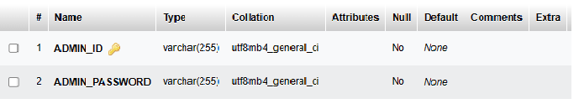

**CARS table structure:** This tables stores cars details

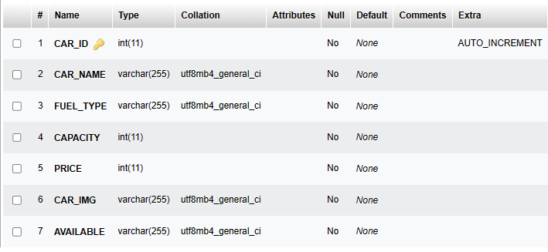

**USER table structure:** This table stores users information

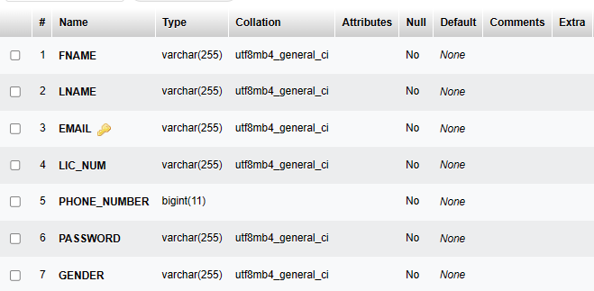

**Booking table structure:** This Table stores the user booking information.

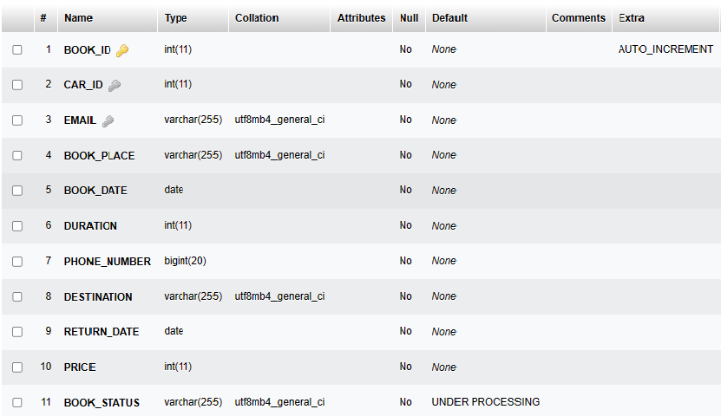

**PAYMENT table structure:** This table stores student details.

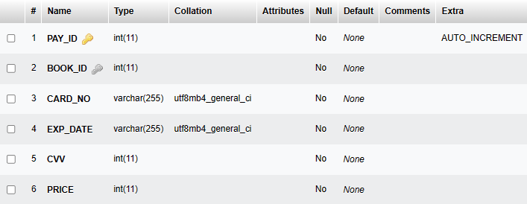

**FEEDBACK table structure :** This stores the feedback details of user.

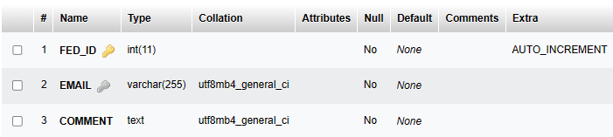

**4.3 Schema Diagram**

Schema is a structure behind data organization. It is visual representation of how different table relationship enable schema’s underlaying mission business rule for which database is created. In schema diagram all database table are designated with unique column and special features.

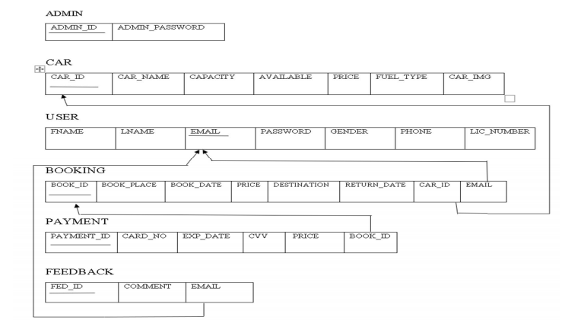

4.3 Schema Diagram

**4.4 ENTITY-RELATIONSHIP Diagrams**

E-R (Entity-Relationship) Diagram is used to represents the relationship between entities in the table.

***The symbols used in E-R diagrams are:***

SYMBOL PURPOSE

Represents Entity sets

Represent attributes.

Represent Relationship Sets.

Line represents flow



Structured analysis is a set of tools and techniques that the analyst.

To develop a new kind of a system:

The traditional approach focuses on the cost benefit and feasibility analysis, Project management, and hardware and software selection a personal considerations.

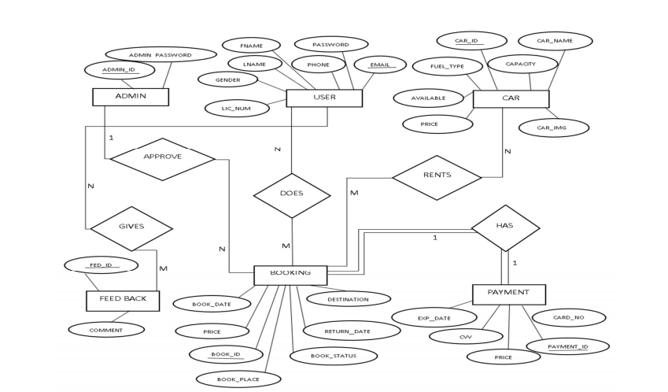

4.4 Entity Relationship Diagram

**4.5 TRIGGERS**

* A database **trigger** is procedural code that is automatically executed in response to certain events on particular table or view in a database.
* The trigger is mostly used for maintaining the integrity of the information on the database.
* Database trigger executed implicitly when a data events such as DML on table (an INSERT, UPDATE, OR DELETE triggering Statement), an INSTEAD OF trigger on a view, or data definition language (DDL)statements such as CREATE and ALTER are issued, no matter which user is connected or which application is used.
* Database triggers also execute implicitly when some user actions or database System action occur, for example, when a user logs on, or the DBA shut downs the database

### **4.6 STORED PROCEDURE**

* A **stored procedure** is subroutines available to application that access a relational database management system (RDBMS). Such procedure is stored in the database data dictionary.
* Uses for stored procedure include data-validation (integrated into the database) or access-control mechanisms. Furthermore, stored procedures can consolidate and centralize logic that was originally implemented in applications.
* To save time and memory, extensive or complex processing that requires execution of several SQL statements can be saved into stored procedures, and all applications call another.
* Stored procedures any return results set, that is the results of a SELECT statement. Such results sets can be procedure using cursors, by other stored procedures, by associating a result-set locator, or by applications.

**Chapter 5**

**SNAPSHOTS AND RESULTS**

* 1. **Home Page**

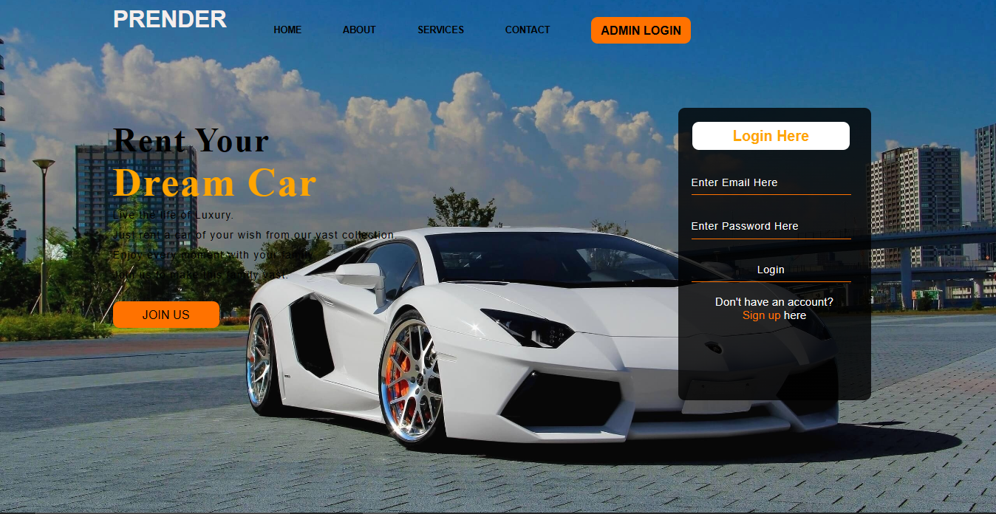

**5.1.1 Admin Login Page**

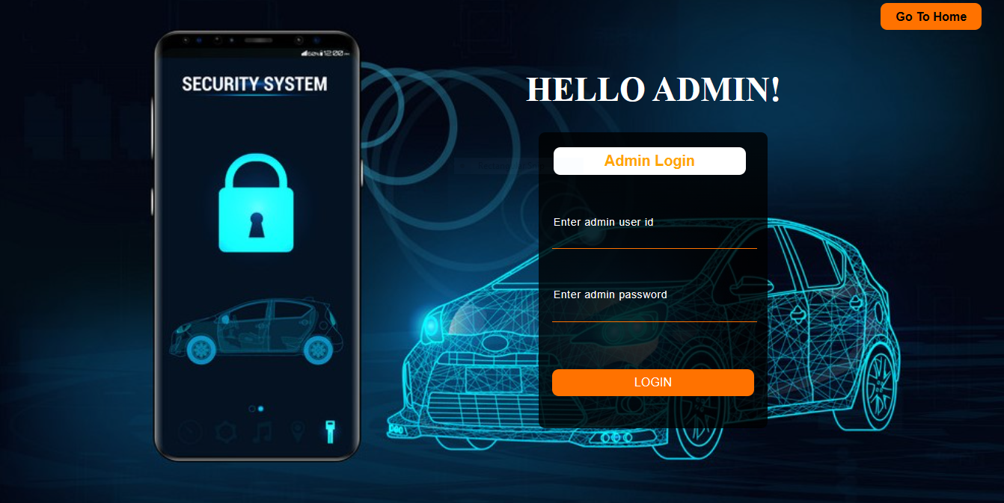

**5.1.1.1 Available Cars**

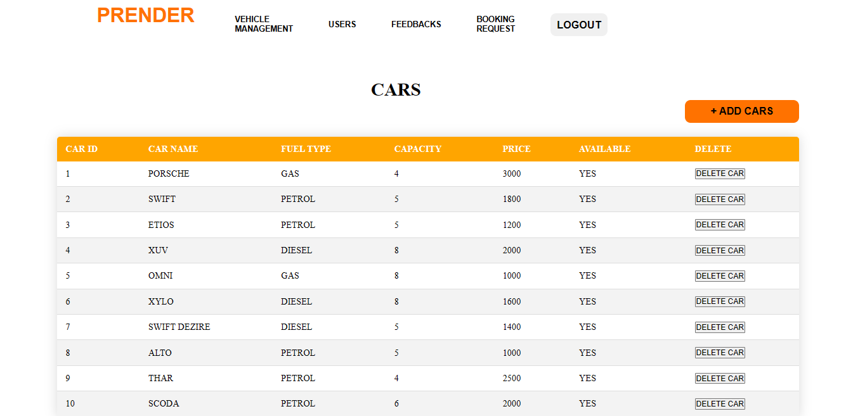

**5.1.1.1.1 Add Car Details**

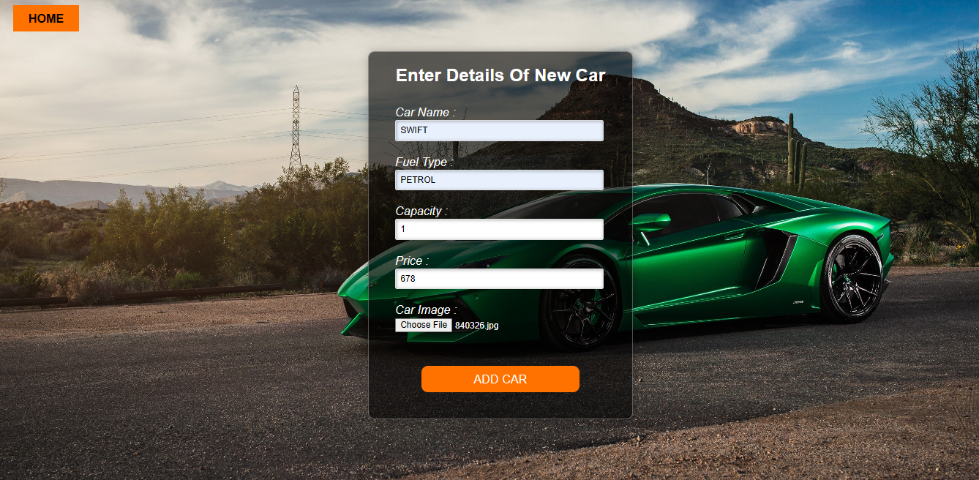

**5.1.1.2 Users Details**

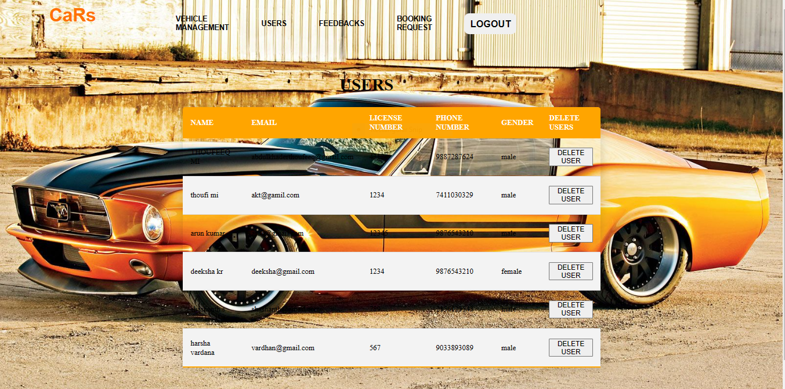

**5.1.1.3 Feedback Dashboard**

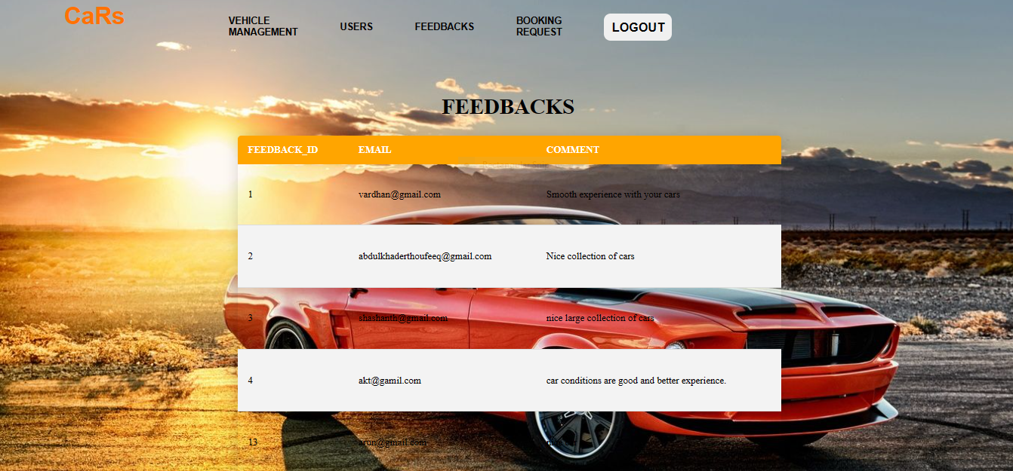

**5.1.1.4 Booking Dashboard**

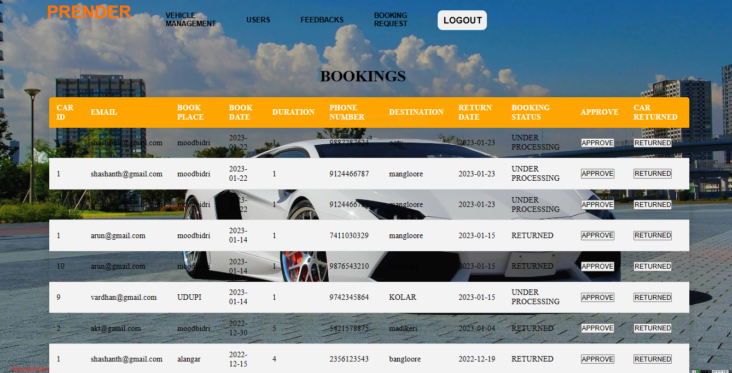

**5.1.2 User Sign-up Page**

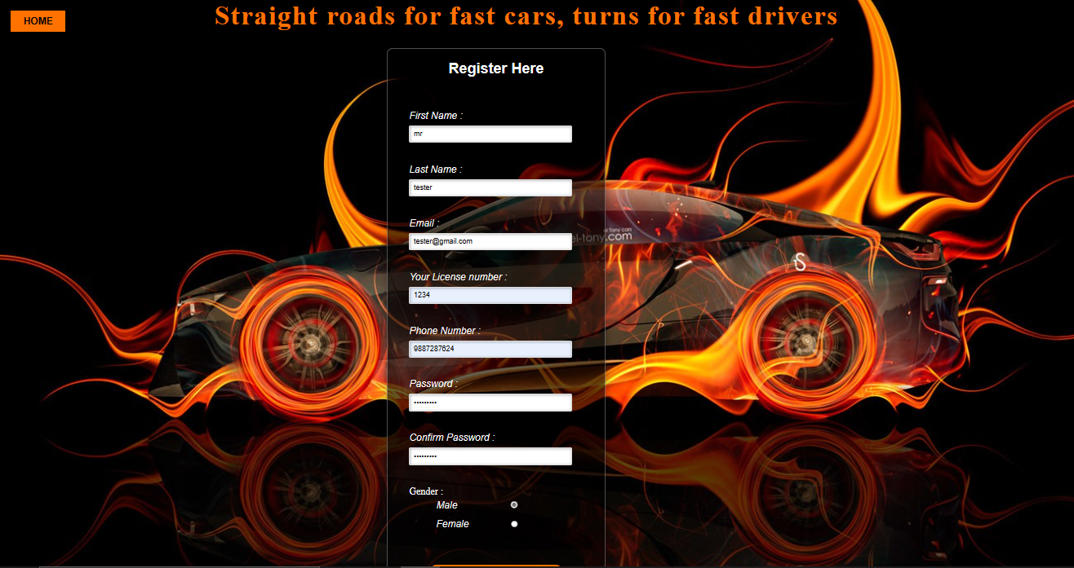

**5.1.3 User Dashboard**

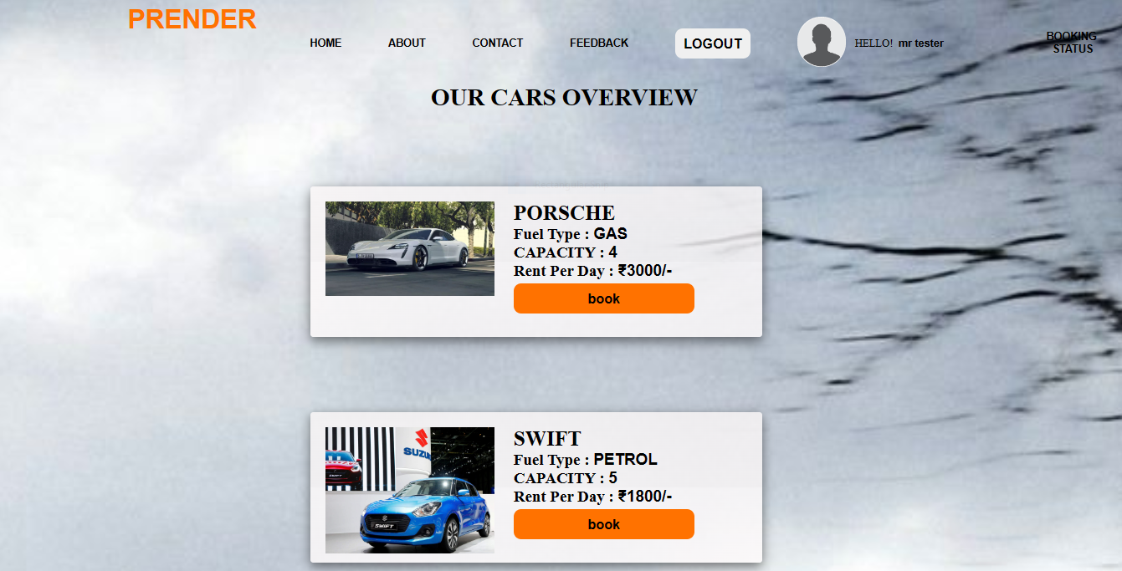

**5.1.3.1 Booking Of Car**

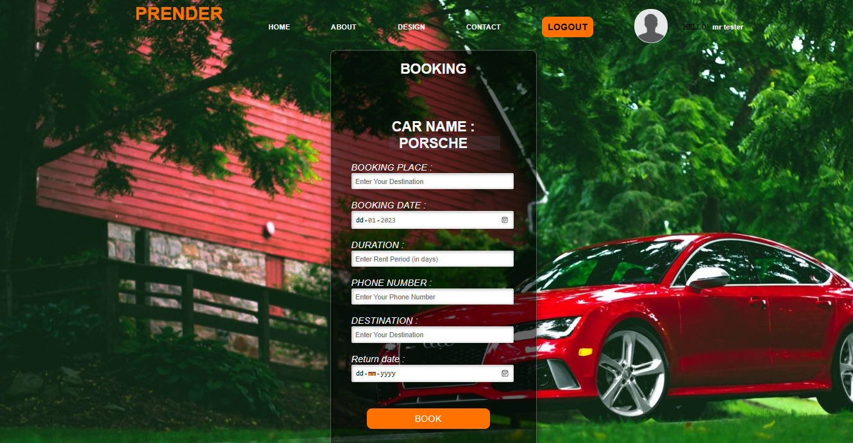

**5.1.3.2 Feedback of User**

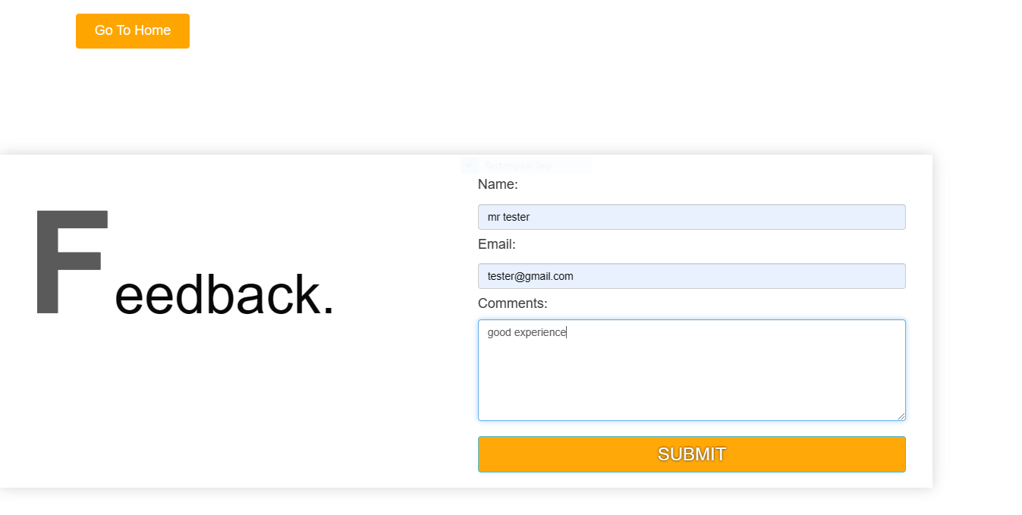

**5.1.3.3 Booking Status**

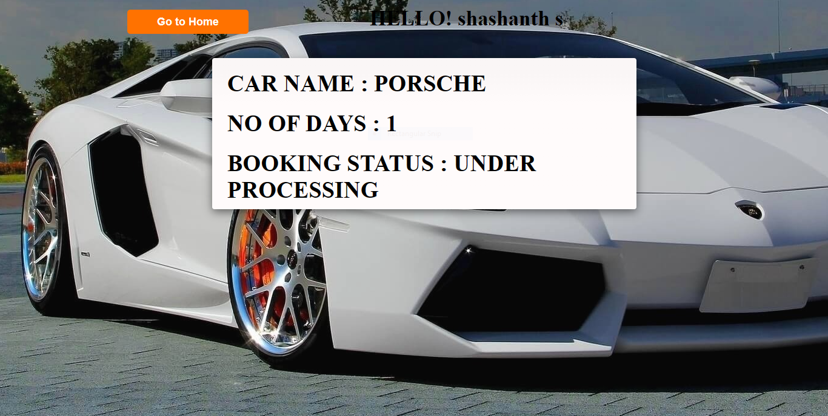

**5.1.4 About us**

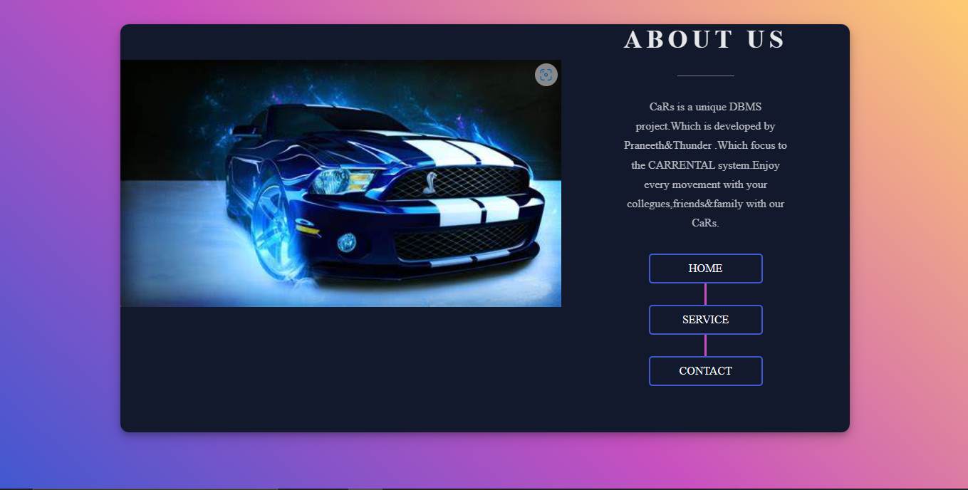

**5.1.5 Contact Us**

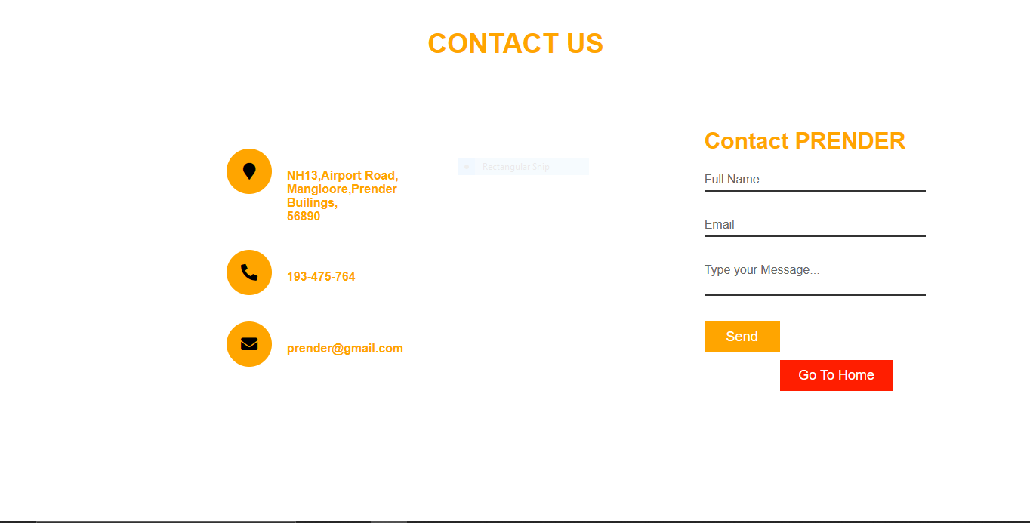

**CHAPTER 6**

**CONCLUSION**

The package was designed in such a way that future modifications can be done easily. The following conclusions can be deduced from the development of the project.

* + Automation of the entire system improves the efficiency
  + It provides a friendly graphical user interface which proves to be better when compared to the existing system.
  + It gives appropriate access to the authorized users depending on their permissions.
  + It effectively overcomes the delay in communications.
  + Updating of information becomes so easier.
  + System security, data security and reliability are the striking features.
  + The System has adequate scope for modification in future if it is necessary.

**CHAPTER 7**

**REFERENCES**

The following books were referred during the analysis and execution phase of the project

* + PHP and MySQL Web Development

Book by Luke Welling

* + Head First PHP & MySQL

Book by Lynn Beighley and Michael Morrison

* + Mastering HTM,CSS and JavaScript

Book by Laura Lemay and Jennifer Kymin

**WEBSITES:**

* [www.google.com](http://www.google.com)
* [www.w3schools.com](http://www.w3schools.com)
* [www.tutorialspoint.php](http://www.tutorialspoint.php)
* http://stackoverflow.com